Experiment No: 02

Name of Experiment: Basic Linux Command.

Object: Our aim is to learn basic Linux command with Linux mint operating system.

Command:

1. whoami: It shows who logged on this system.

Basic syntax: whoami

Output:

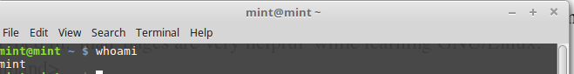

1. hostname: It tells on which machine you are.

Basic syntax: hostname

Output:

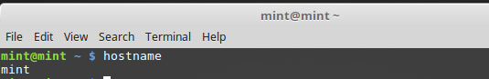

1. pwd: It shows the path of current working director.

Basic syntax: pwd

Output:

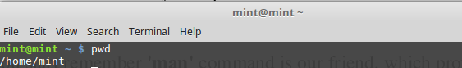

1. cd : It brings us to the highest level of your home directory of computer

Basic syntax: cd

Output:

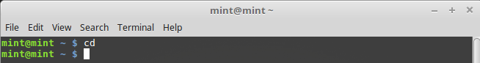

1. cd .. : It moves one directory up.

Basic syntax: cd ..

Output:

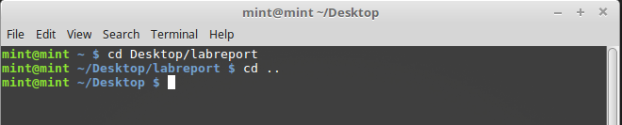

1. cd ../ ../ : It moves two directories up (and so on)

Basic syntax: cd ../ ../

Output:

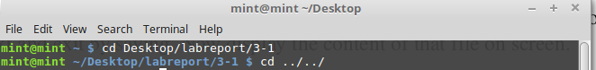

1. cd <dir_name> : It switches to 'dir_name' directory

Basic syntax: cd Desktop

Output:

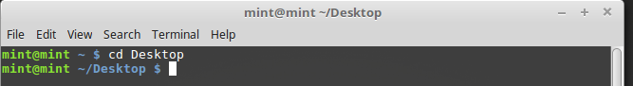

1. ls : It displays the list of files in the current working directory

Basic syntax: ls

Output:

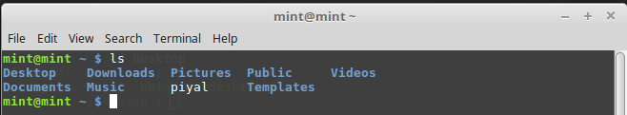

1. mkdir <dir_name>:It creates a directory with specified 'dir_name'.

Basic syntax: mkdir labreport

Output:

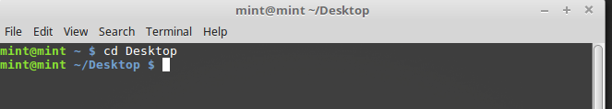

1. touch: It creates files.

Basic syntax: touch myfile.txt

Output:

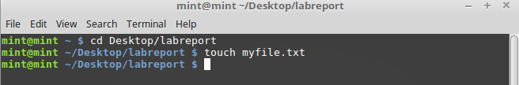

1. find: It finds out file from a specific directory.

Basic syntax: find Desktop/labreport/profile.txt

Output:

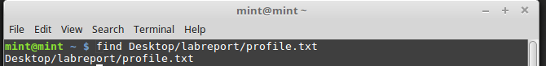

1. vi: It views a file contents.

Basic syntax: vi profile.txt

Output:

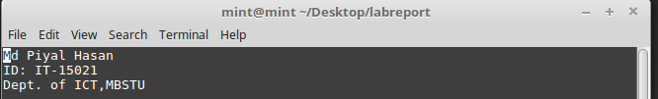

1. mv <name1> <name2>: It renames the directories or files.

Basic syntax: mv myfile.txt profile

Output:

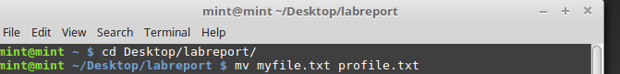

1. cp <name> <path> : It copies file/directory as specified in path

Basic syntax: mv myfile.txt profile

Output:

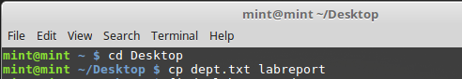

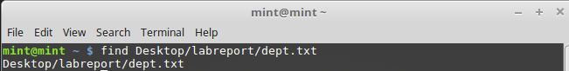

1. rmdir <dir_name> : It removes entire directory.

Basic syntax: rmdir Dept

Output:

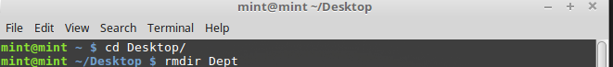

1. rm <file_name> : It removes file name.

Basic syntax: rm pi.txt

Output:

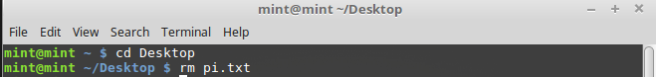

Conclusion: In this lab experiment, we learn about linux basic command. It helps us to develop future project in Linux operating system.